From:

Society Is Made Of Narrative. Realizing This Is Awakening From The Matrix.

Caitlin Johnstone
Following
Aug 21, 2018 · 12 min read


In the movie The Matrix, humans are imprisoned in a virtual world by a powerful artificial intelligence system in a dystopian future. What they take to be reality is actually a computer program that has been jacked into their brains to keep them in a comatose state. They live their whole lives in that virtual simulation, without any way of knowing that what they appear to be experiencing with their senses is actually made of AI-generated code.
Life in our current society is very much the same. The difference is that
- instead of AI, it’s psychopathic oligarchs who are keeping us asleep in the Matrix. And
- instead of code, it’s narrative.
Society is made of narrative like the Matrix is made of code.
- Identity,
- language,
- etiquette,
- social roles,
- opinions,
- ideology,
- religion,
- ethnicity,
- philosophy,
- agendas,
- rules,
- laws,
- money,
- economics,
- jobs,
- hierarchies,
- politics,
- government,
they’re all purely mental constructs which exist nowhere outside of the mental noises in our heads. If I asked you to point to your knee you could do so instantly and wordlessly, but if I asked you to point to the economy, for example, the closest you could come is using a bunch of linguistic symbols to point to a group of concepts. To show me the economy, you’d have to tell me a story.

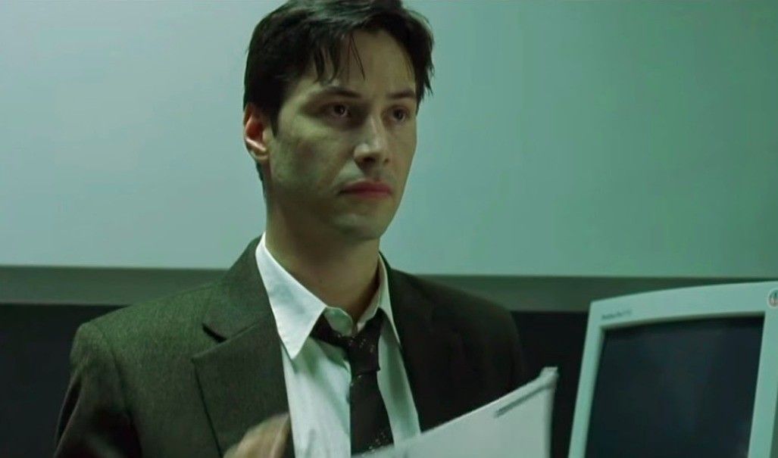
Anyone who has ever experienced a moment of mental stillness knows that without the chatter, none of those things are part of your actual present experience. There is no identity, language, etiquette, social roles, opinions, ideology, religion, ethnicity, philosophy, agendas, rules, laws, money, economics, jobs, hierarchies, politics or government in your experience without the mental chatter about those things. There’s not even a “you” anywhere to be found, because it turns out that that’s made of narrative, too.
Without mental narrative, nothing is experienced but sensory impressions appearing to a subject with no clear shape or boundaries. The visual and auditory fields, the sensation of air going in and out of the respiratory system, the feeling of the feet on the ground or the bum in the chair. That’s it. That’s more or less the totality of life minus narrative.
When you add in the mental chatter, however, none of those things tend to occupy a significant amount of interest or attention. Appearances in the visual and auditory field are suddenly divided up and labeled with language, with attention to them determined by whichever threatens or satisfies the various agendas, fears and desires of the conceptual identity construct known as “you”. You can go days, weeks, months or years without really noticing the feeling of your respiratory system or your feet on the ground as your interest and attention gets sucked up into a relationship with society that exists solely as narrative.
“Am I good enough? Am I doing the right thing? Oh man, I hope what I’m trying to do works out. I need to make sure I get all my projects done. If I do that one thing first it might save me some time in the long run. Oh there’s Ashley, I hate that bitch. God I’m so fat and ugly. If I can just get the things that I want and accomplish my important goals I’ll feel okay. Taxes are due soon. What’s on TV? Oh it’s that idiot. How the hell did he get elected anyway? Everyone who made that happen is a Nazi. God I can’t wait for the weekend. I hope everything goes as planned between now and then.”
On and on and on and on. Almost all of our mental energy goes into those mental narratives. They dominate our lives. And, for that reason, people who are able to control those narratives are able to control us.
And they do.

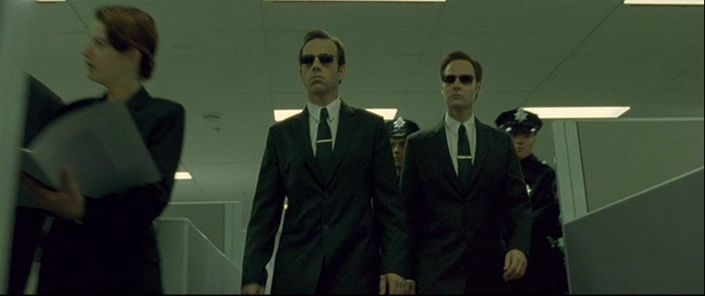
Most people try to exert some degree of control over those around them. They try to influence how those in their family, social and employment circles think of them by behaving and speaking in a certain way. Family members will spend their lives telling other family members over and over again that they’re not as smart/talented/good as they think they are to keep them from becoming too successful and moving away. Romantic partners will be persuaded that they can never leave because no one else will ever love them. To varying degrees, they manipulate the narratives of individuals.
Then there are the people who’ve figured out that they can actually take their ability to influence the way people think about themselves and their world and turn it into personal profit. Cult leaders convince followers to turn over their entire lives in service to them. Advertisers convince consumers that they have a problem or deficiency that can only be solved with This Exciting New Product™. Ambitious rat race participants learn how to climb the corporate ladder by winning favor with the right people and inflicting small acts of sabotage against their competing peers. Ambitious journalists learn that they progress much further in their careers by advancing narratives that favor the establishment upon which the plutocrats who own the big media companies have built their kingdoms. They manipulate the narratives of groups.
And then, there are the oligarchs. The master manipulators. These corporate kings of the modern world have learned the secret that every ruler since the dawn of civilization has known: whoever controls the narratives that are believed by a society is the controller of that society. Identity, language, etiquette, social roles, opinions, ideology, religion, ethnicity, philosophy, agendas, rules, laws, money, economics, jobs, hierarchies, politics, government: all mental constructs which only influence society to the extent that they are believed and subscribed to by a significant majority of the collective. If you have influence over the things that people believe about those mental constructs, you have influence over society. You rule it. The oligarchs manipulate the narratives of entire societies.

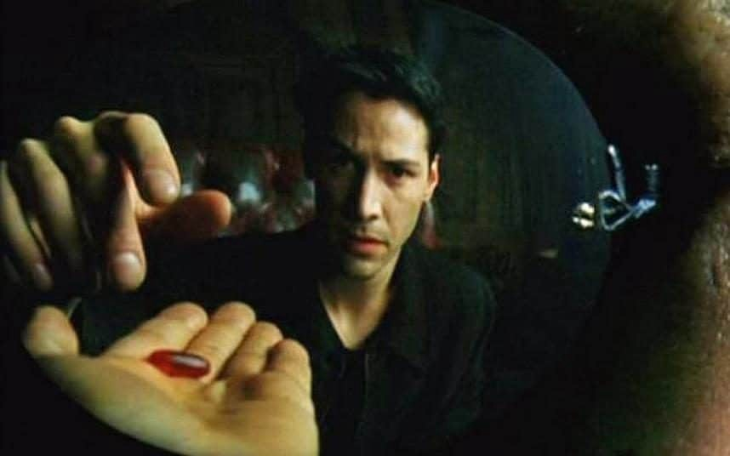
This is why there have been book burnings, heretic burnings, and executions for mocking the emperor throughout history: ideas which differ from the dominant narratives about what power is, how money works, who should be in charge and so on are threatening to a ruler’s power in the exact same way that an assassin’s dagger is. At any time, in any kingdom, the people could have decided to take the crown off of their king’s head and place it upon the head of any common beggar and treat him as the new king. And, in every meaningful way, he would be the new king. The only thing preventing this from happening was dominant narratives subscribed to by the society at the time about Divine Right, fealty, loyalty, noble blood and so on. The only thing keeping the crown on a king’s head was narrative.
The exact same thing remains true today; the only thing that has changed is the narratives the public subscribe to. Because of what they are taught in school and what the talking heads on their screens tell them about their nation and their government, most people believe that they live in a relatively free democracy where accountable, temporary power is placed in the hands of a select few based on a voting process informed by the unregulated debate of information and ideas. Completely separate from the government, they believe, is an economy whose behavior is determined by the supply and demand of consumers. In reality, economics, commerce and government are fully controlled by an elite class of plutocrats, who also happen to own the media corporations which broadcast the information about the world onto people’s screens.
Control the narratives of economics and commerce, and you control economics and commerce. Control the narratives about politics and government, and you control politics and government. This control is used by the controllers to funnel power to the oligarchs, in this way effectively turning society into one giant energy farm for the elite class.
But it is possible to wake up from that narrative Matrix.

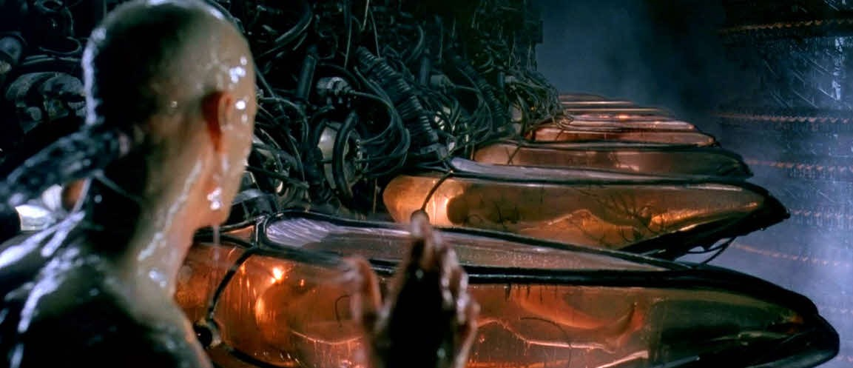
It isn’t easy, and it doesn’t happen overnight. It takes work. Inner work. And humility. Nobody likes acknowledging that they’ve been fooled, and the depth and extent to which we’ve all been fooled is so deeply pervasive it can be tempting to decide that the work is complete far before one is actually free.
- Mainstream American liberals think they’re clear-eyed because they can see the propaganda strings being pulled by Fox and Donald Trump, and
- mainstream American conservatives think they’re clear-eyed because they can see the propaganda strings being pulled by MSNBC and the Democrats,
but the propaganda strings on both trace back to the same puppet master.And seeing that is just the beginning.
But, through sincere, humble research and introspection, it is possible to break free of the Matrix and see the full extent to which you and everyone you know has been imprisoned by ideas which have been programmed into social consciousness by the powerful. Not just in our adult lives, but ever since our parents began teaching us how to speak, think and relate to the world. Not just in the modern world, but as far back as history stretches to when the power-serving belief systems of societal structure and religion were promoted by kings and queens of old. All of society, and all of ourselves, and indeed all of the thoughts in our heads, have been shaped by those in power to their benefit. This is the reality that we were born into, and our entire personality structure has been filtered through and shaped by it.
For this reason, escaping from the power-serving propaganda Matrix necessarily means becoming a new creature altogether. The ideas, mental habits and ways of relating to the world which were formed in the Matrix are only useful for moving around inside of it. In order to relate to life outside of the power-promulgated narratives which comprise the very fabric of society, you’ve got to create a whole new operating system for yourself in order to move through life independently of the old programming designed to keep you asleep and controlled.
So it’s hard work. You’ll make a lot of mistakes along the way, just like an infant slowly learning to walk. But, eventually, you get clear of the programming.
And then you’re ready to fight.

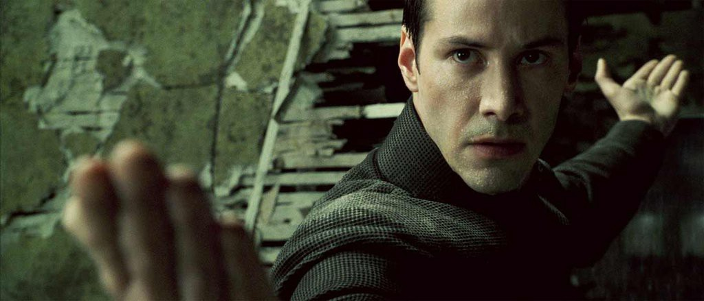
Because at some point in this process, you necessarily come upon a deep, howling rage within. Rage at the oligarchic manipulators of your species, yes, but also rage against manipulation in all its forms. Rage against everyone who has ever tried to manipulate your narrative, to make you believe things about yourself or make other people believe things about you. Rage against anyone who manipulates anyone else to any extent. When your eyes are clear manipulation stands out like a black fly on a white sheet of paper, and your entire system has nothing to offer it but revulsion and rejection.
So you set to work. You set to work throwing all attempts to manipulate you as far away from yourself as possible, and expunging anyone from your life who refuses to stop trying to control your narrative.
- Advertising,
- mass media propaganda,
- establishment academia,
- everything
gets purged from your life that wants to pull you back into the Matrix.
And they will try to pull you back in. Because our narratives are so interwoven and interdependent with everyone else’s, and so inseparable from our sense of ourselves, your rejection of the narrative Matrix will present as an existential threat to many of your friends and loved ones. You will see many people you used to trust, many of them very close to you, suddenly transform into a bunch of Agent Smiths right in front of your eyes, and they will shame you, guilt you, throw every manipulation tool they have at you to get you to plug the jack back into your brain. But because your eyes are clear, you’ll see it all. You won’t be fooled.
And then all you’ll want is to tear down the Matrix from its very foundations and plunge its controllers into irrelevance. You will set to work bringing down the propaganda prison that they have built up around your fellow humans in any way you can, bolt by bolt if you have to, because you know from your own experience that we are all capable of so much more than the puny gear-turning existence they’ve got everyone churning away at. You will despise the oligarchs for the obscene sacrilege that they have inflicted upon human majesty out of greed and insecurity, and you will make a mortal enemy of the entire machine that they have used to enslave our species.
And, because their entire kingdom is built upon maintaining the illusion of freedom and democracy, all they will have to fight back against you is narrative. They’ll try to shame you into silence by calling you a conspiracy theorist, they’ll have their media goons and manipulators launch smear campaigns against you, but because your eyes are clear, none of that will work. They’ve got one weapon, and it doesn’t work on you.

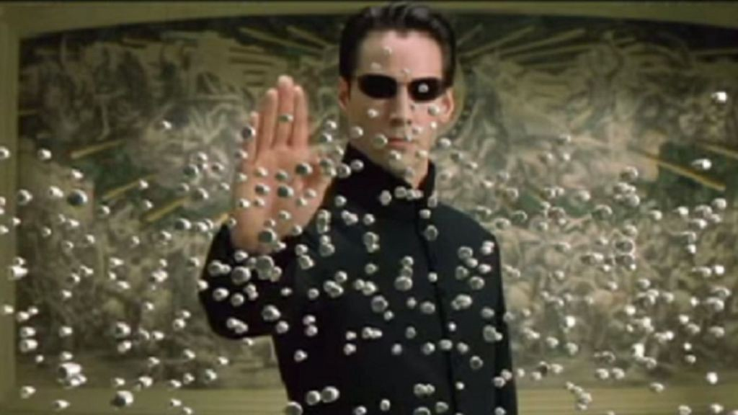
And you will set to work waking up humanity from the lie factory, using whatever skills you have, weakening trust in the mass media propaganda machine and opening eyes to new possibilities. And while doing so, you will naturally shine big and bright so the others can find you. And together, we’ll not only smash the narratives that imprison us like a human caterpillar swallowing the narrative bullshit and forcing it into the mouth of the next slave, but we’ll also create new narratives, better narratives, healthier narratives, for ourselves and for each other, about how the world is and what we want it to be.
Because here’s the thing: since it’s all narrative, anything is possible. Those who see this have the ability to plunge toward health and human thriving without any regard for the made-up reasons why such a thing is impossible, and plant seeds of light which sprout in unprecedented directions that never could have been predicted by someone plugged into to establishment how-it-is stories. Together, we can determine how society will be. We can re-write the rules. We are re-writing the rules. It’s begun already.
Out of the white noise of a failing propaganda machine, a new world is being born, one that respects the autonomy of the individual and their right to self-determination. One that respects our right to collaborate on large scales to create beautiful, healthy, helpful systems without the constant sabotage and disruption of a few power-hungry psychopaths who would rather rule than live. One that respects our right to channel human ingenuity into harmony and human thriving instead of warfare and greed. One that respects our right to take what we need, not just to survive but to thrive, and return it to the earth for renewal. One that respects the sovereign boundaries of not just ourselves and each other, but of the planet spaceship that we live in.
Unjack your cortex fully from the fear-soaked narratives of insanity, and let the true beauty of our real world flood your senses. Let the grief of what we have unknowingly done send you crashing to your knees in sorrow. And when you’re ready, stand up. We have much work to do.




